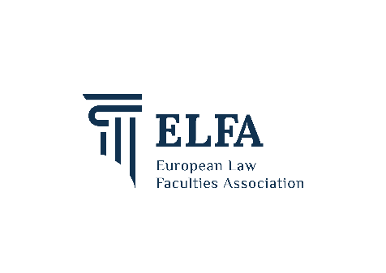

REGISTRATION FORM

ELFA Annual Meeting and Conference 2023

Lausanne, 12 - 14 April 2023

REGISTRATION DETAILS
Title and Name
University or Institution
Position
Address
Postal Code and City
Country
E-mail
Telephone

CONFERENCE MEALS (1 person included in Conference fee)
Yes, I will attend the reception on Wednesday 12 April 2023
Yes, I will attend the official Conference dinner on Thursday 13 April 2023
Yes, I will attend the lunch on Friday 14 April 2023
Special dietary requirements (please specify vegetarian or other restrictions):

REGISTRATION FEE

Important: One delegate of each ELFA Member Faculty is not required to pay the registration fee, on the condition that the member faculty has already paid annual membership fees. For each additional delegate of an ELFA member, the registration fee is fixed at € 150,-For Non ELFA Members the fee is € 210,-

Number of person(s)
 | First Delegate from an ELFA Member: | Free | FREE
 | Additional Delegate(s) from an ELFA Member: | € 150,- for Each Person
 | Delegate from a Non ELFA Member: | € 210,- for Each Person
 | Accompanying Person | Official Dinner 13 April: € 100
TOTAL AMOUNT:

Please send me an invoice if more than one delegate attending

PAYMENT: Registration will not be valid until the required fee has been received. Payments can only be made in Euro.

The ELFA Bank details are:

Bank | BNP PARIBAS FORTIS
Address | Vital Decosterstraat 42, B 3000, Leuven, Belgium
IBAN | BE03 2300 1895 0584
BIC / SWIFT Code | GEBABEBB
Holder | EUROPEAN LAW FACULTIES ASSOCIATION (ELFA)  Tiensestraat 41, B 3000 – Leuven (Belgium)  Tax Identification Number (BE): 206/5893/1271  RSIN - Legal Entity or Partnership Identification Number (NL): 819322350

Please indicate your name clearly on all money transfers, and email a scanned proof of transfer (if possible) to: elfa.agm@gmail.com

CANCELLATION: In case of cancellation the total fee minus handling charges will be refunded, provided a written request is received by ELFA before 17 March 2023.

Please return this form by 17 MARCH 2023 sending it BY EMAIL to: elfa.agm@gmail.com

